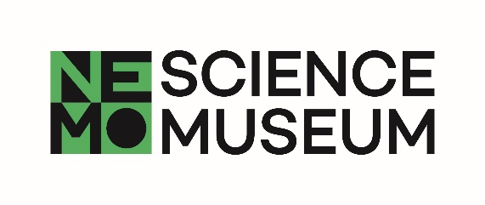**SCIENCE LIVE**

**Take part in science**

**Consent form minors**

**Title of study:** How good are you at lying and detecting lies?

**Head scientist(s):** Prof. Dr. Theo Gevers, Prof. dr. Albert Ali Salah

**Researchers:** Dr. Sezer Karaoglu, Dr. Sophie van der Zee, Dr. Ronald Poppe

**University / Department**:University of Amsterdam – Informatics Institute, Utrecht University - Department of Information and Computing Sciences, Erasmus University Rotterdam - Erasmus School of Economics

Dear participant,

Thank you for participating in Science Live, the research program of NEMO Science Museum. The research you participate in is conducted by researchers from the University of Amsterdam, Utrecht University and Erasmus University Rotterdam.

In this experiment, you will be both liar and lie detector. You'll start with filling in a questionnaire so we can get to know you. We will use it to understand if some traits will help you in telling or spotting lies. Then it's your turn to describe something you've seen and something you haven't. With various cameras and microphones we will record every move and word. Then the tables are turned and we'll investigate how well you can spot lies by watching short clips of other participants. We'll also see if you can catch your family members red handed! We keep track of the best liar, but also who's our best lie detector.

No reward is given for participation. The regular liability insurance of the University of Amsterdam applies to this research.

The experiment takes about 15 minutes for you and your family together. **You can stop the experiment at any time, without need for explanation.** Just let the researcher know.

All research data and recordings remain confidential and are processed anonymously. The research data is disconnected from names; only the principal investigator has access to names.

The anonymized data and recordings will be used exclusively for scientific research. Your data (including audio and video recordings) can be shared with other researchers for research. Your data will **not** be used for (scientific) presentations, publications, and (social) media (including TV, radio, online and printed media) and will also **not** be used for commercial purposes. Your data will also not be used by NEMO Science Museum.

**Dear parent/guardian,**

**would you be so kind as to fill out and sign the consent form on the back of this page?**

Hereby, I, the undersigned parent/guardian of the minor named below, declare, with respect to NEMO (Stichting Nationaal Centrum voor Wetenschap en Technologie) at Oosterdok 2 in Amsterdam, that:

on [date]…………………………………,

[first and last name of minor]…………………………… …………………………………

has participated in research mentioned and described on the front of this form. By signing this form I give explicit permission for him/her to participate in this research within NEMO's Science Live program.

First and last name of parent/guardian:……………………………………………………………………………………………….

Signature: ………………………………………………………………………….